**A Minor Project**

**On**

**“Student’s performance analysis”**



**Submitted to**

**Department of Computer Science and Application**

**U.T.D. AtAL BIHARI VAJPAYEE University**

**For**

**The Degree of**

**“Bachelor of Computer science”**

**Under Guidance of: - Submitted By:-**

**Dr. H.S. Hota tushar kashyap**

**Prof. jeetendra gupta thanendra kashyap**

**sandeep girepunje**

**B.Sc. CSA 6th sem**

**Session 2019-20**

**CERTIFICATE**

This is to certify that the project titled “**Student’s performance analysis** carried out by **tushar kashyap, thanendra kashyap, sandeep girepunje** under my guidance and supervision for award of the degree **Bachelor of Science** in faculty of **Computer Science & Application of ATAL BIHARI VAJPAYEE University, Bilaspur (C.G.)**

To the best of my Knowledge and belief the projects:-

* Embodies the work of the candidate himself.
* Has duty been complete in specified time.
* Fulfills the requirements of the ordinance relating to B.Sc./M.Sc. Degree of the University.

Is up to the standard in respect of content and language for being referred to the examiners.

**Signature:-**

**ACKNOWLEGEMENT**

We have taken efforts in this project. However, it would not have been possible without the kind support and help of many individuals and organizations. We would like to extend my sincere thanks to all of them.

We are highly indebted to **Prof. Jeetendra Kumar Gupta** for his guidance and constant supervision as well as for providing necessary information regarding the project & also for their support in completing the project.

We would like to express my deep sense of gratitude towards **Prof. Shriya Sahu** for her valuable guidance, co-operation and approval given by them in successful completion of project work.

Our thanks also goes to **Prof. Himanshu sahu** and **Prof. Prerna verma** (guest faculties) in developing the project, who have willingly helped us out with their abilities.

**Submitted By:-**

**Tushar kashyap**

**Thanendra kashyap**

**Sandeep girepunje**

**DECLARATION**

This is to certify that we **TUSHAR KASHYAP, THANENDRA KASHYAP** and **SANDEEP GIREPUNJE**, Students of 6th sem. B.Sc. (Department of Computer Science and Application), session 2019-20, hereby declare that project work entitled **“Student’s Performance analysis”** has been carried out by us under the supervision of Internal Guide **Mr. Jeetendra Kumar Gupta** (Asst. Professor) from the Department of Computer Science and Application and submitted the major project report of B.Sc. (Computer Science) by Department of Computer Science & Applications, UTD ATAL BIHARI VAJPAYEE University, Bilaspur (C.G.), during the academic year 2019-20. This is an original work carried out by us.

**DATE: 15/05/2020** **Tushar Kashyap**

**PLACE: Bilaspur** **Thanendra Kashyap**

**Sandeep Girepunje**

**B.Sc. (C.S.A.) 6th Sem.**

**U.T.D., A.B.V. University**

**INDEX**

* INTRODUCTION:-
  + - * Student’s performance analysis ……………………………
      * objective
      * Purpose
      * Scope
      * Technology used
      * System Requirement
      * Software Development Life Cycle
      * The SRS Model
* Feasibility Study
* Economically Feasibility
* Technical Feasibility
* Behavioral Feasibility

**INTRODUCTION:-**

Any website or softwere is created so that we can make our work eaiser by using It, here we have created such a website, where the student can know some information such as name, email id, date of birth etc. by knowing his /her week point and analyzing his/her performance so that the teacher can improve that week point.

This project is to predict performance of a student based on certain attributes of the students such as his semester attendance, unit test marks, last semester exam.

**Objective:-**

* The main objective of this project is to analyze the performance of a student by knowing his week point and to improve his week point.
* Student's learning ability can be improved by the teacher.
* Teachers can understand the problems student facing while learning, and he/she could solve student’s problem.

* Student can overcome his/her weakness with the help of statistics of his/her performance.
* Teachers will know the reasons why students can’t focus on subjects or the reasons of student’s distraction.
* This can improve the communication or interaction between student and teacher

**Purpose:-**

* The purpose of Student Performance Analysis is to monitor student’s learning ability and the ability for adapting the current teaching program at university.
* The Concept is, student can register himself/herself to the Student Performance Analysis program and at the end of the semester they take a survey.
* Based on the survey in Student Performance Analysis we collect information from the student and with this data, we can analyse student’s performance of learning
* With this program, we can see what problem student’s facing while learning, for ex. Low Attendance, Interest in subject, Focus in classes, and many other issues.
* Teachers can see student’s performance statistics but can’t see the answers of student’s survey, which will be confidential for student’s privacy.

**Scope of the project :-**

Anyone who has ever done a project will have tales of how scope c hanges caused grief. Scope is bound to change, and this is to be expected. As the detail becomes clearer, more complications creep in. These are not foreseeable at the start and hopefully I build in a c ontingency for what we cannot see. The scope changes that usually c ause problems are those where the perception of what was in and out of scope was different between various. parties

The Scope of the project mean normally expecting the result of s something. Scope is same like the motivation and objectives. But there some more special in this case. Scope is really expecting, as we take our system, we have to think why we are using computerized system rather other paper base, and we have to think what purpose of that system.

Why we need computerized system, actually today’s world we can’t maintain or manage the things without proper system or computer. Now computers are merge with our life. So the computer based systems are very popular, and that’s very secure rather than paper base system. If we tell one example there were happened a flood disaster, and all the paper based records can be Drench to the water. Then we cannot recover the important information. These kind of situation we can recover the information by using computerized system. Just remove the hard disk and recover the file easily

And security is high, because using computerized system is not allow to use any peoples without their accounts or authorized permission. So the paper base is not like that, anyone can see the information and they can do for that information whatever they want.

As my project also a computerized system called Student’s feedback form.

**System Requirement Specification :-**

**Product Features:-**

As soon as we click on in this website, there are three option in front of us student ,teacher and admin.

* **Login interface:-**

**Student login-**

User should enter the valid enrollment id and password to get access to its profile.

If you are a new user than you will have to sign in by filling some details such as name , father name , email id,mobile number and department etc. so that you will get the enrollment id and password so that you can log in.

**Homepage:-** user can check their performance here such as attendance,classwork and other activity.

**Teacher login:-**

Here the user can login by filling the email id and password and can analyze the performance of the student.

**Homepage:-** There are some option like courses,course modification and course list.

Where user profile,verified student list and subject , section inside the courses. and where there is an option of add course, course modify and removal course within course modification. Where the user can add and modify the course and can remove the course. And inside the course list is the course name and information related to it.

**Admin login:-**

User should enter the user id and password to get access to its profile.

The teacher sent the varifiy student data to admin and admin are cross check the data and sends it back to the teacher section and the teacher analyze the students performance.

**Operating Environment:-**

* Operating system : window 10

Intel P4 1.5GHz or above.

* 512MB ram.
* 80GB HDD Minimum.

**User Classes:-**

* System Owner: The Student
* System Users:
  + - * Administrators: has full privilege on the system's functions
      * Public: student can give only feedback form

**Design Constraints:-**

* GUI will be only on English

**Non Functional Requirements**

**Availability**

* The system should be available at all times, meaning the user can access it using application.
* In case of a of a hardware failure or database corruption, a replacement page will be shown. Also in case of a hardware failure or database corruption, backups of the database should be retrieved from the application data folder and saved by the administrator.
* It means 24 x 7 availability.

**Security**

* The system use SSL (secured socket layer) in all transactions that include any confidential customer information.
* The system must automatically log out all customers after a period of inactivity

**Performance**

* The system is interactive and the delays involved are less.
* When connecting to the server the delay is based editing on the distance of the 2 systems and the configuration between them so there is high probability that there will be or not a successful connection in less than 20 seconds for sake of good communication.

**Reliability**

* As the system provide the right tools for problem solving it is made in such a way that the system is reliable in its operations and for securing the sensitive details.

**Process Model**

For Student’s feedback form the process model suitable is Iterative Waterfall Model

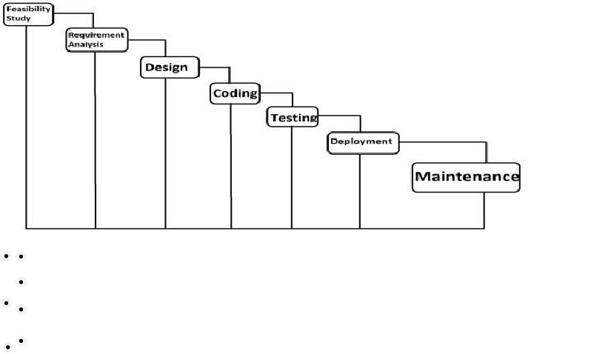

**Advantages**

* Easy to understand and implement
* Testing in each phase.
* Documentation Available after each phase.
* Most Suitable for single projects where work products are well defined and their functioning is understood.

**Disadvantages**

* Once detecting error at any face it may be required that the precede subsidy faces may change.
* Very difficult to manage changes b/w the phases there are possibility of blocking which can slow down the productivity and efficiency of the process.
* Risk is not addressed in this model

**Advantage of Model in this System**

* Easy to Understand
* It is the basic model of all models.
* Errors are detected after each Phase of Development.
* It is Single and Small Project.

**Feasibility study**

A feasibility study involves whether the project is possible to implement or not. The criteria to judge feasibility are cost required, technical value, delivered etc. A well-designed study should offer a historical background of the business or project, a description of the product or service, accounting statements, details of operations and management, marketing research and policies, financial data, legal requirements and tax obligations. Generally, such studies precede technical development and project implementation.

A feasibility study evaluates the project's potential for success; therefore, perceived objectivity is an important factor in the credibility of the study for potential investors and lending institutions. Our project deals with the feasibility of student’s feedback form. Feasibility studies can be divided in to various types i.e.

**Economic Feasibility**

* The Cost of doing full project minimum.
* Estimated price of hardware and software are affordable.

**Technical Feasibility**

* Accuracy
* Reliability
* Security

**Operational Feasibility**

* Sufficient support for online feedback.
* Work properly if it is being developed and implemented.
* Easy to maintain

**Working of Present System**

In the present time there is no system for the students performance analysis in our university.

**Limitation of Present System**

* **Not user friendly:**

The existing system is not user friendly because the retrieval of data is very slow and data is not maintained efficiently.

* **Difficult in Report Generating:**

We required more calculation to generate the report so it is generated at the end of the session. And the student not gets a single chance to improve their feedback.

* **Manual control:**

All calculation to generated repot is done manually so there is greater chance of error.

* **Time Consuming:**

Every work is done manually so we cannot generate report in the middle of the sessionor as per therequirement because it is a very time consuming.

**Feature of the New System**

The new system has been designed as per the user requirement so as to fulfill almost all them.

* **User Friendly :**

The proposed system is user friendly because the retrieval and storing of data is fast and data is maintained efficiently. Moreover the graphical user interface is provided in the proposed system, which provides user to deal with the system very easily.

* **Report are easily generated:**

Report can be easily generated in the proposed system so user can generate the report as per the requirement or in the middle of the session.

* **Very Less Paperwork :**

The proposed system requires very less paperwork. All the data is feted into the computer immediately and report can be generated through computer.

**Data Tables**

A data table is a collection of related data held in a structured format within a database. It consists of rows and columns. Each row is identified by one or more values appearing in a particular columns subset. The column subset which uniquely indentifies a row called the primary key.

* **Student Login Table:**

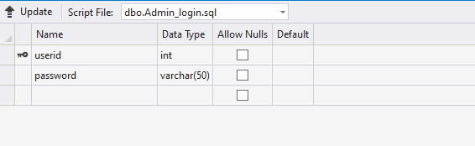

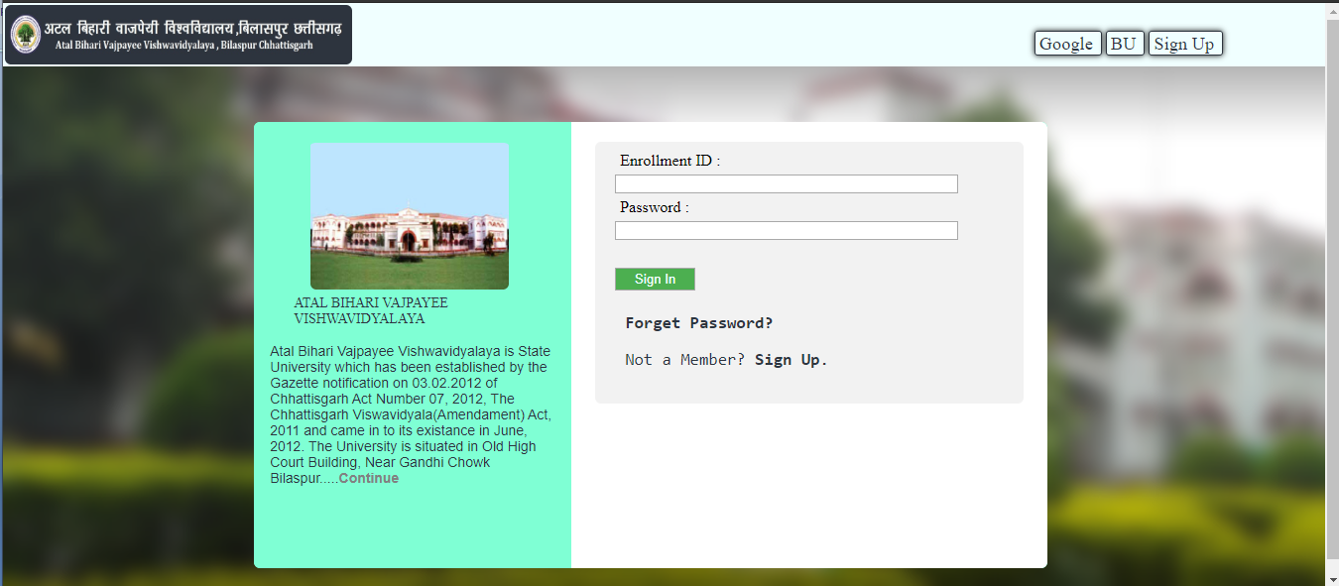

* **Student registration Table:-**

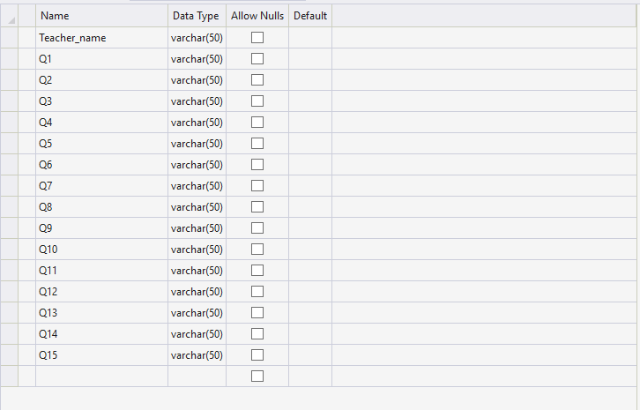

**ER Diagram**

An Entity Relation (ER) diagram is a type of flowchart that illustrate how “Entities” such as people ,object or concept related to each other within a system, ER diagram are most often used to design are debug relation database in the field of software engineering business information system education and research.

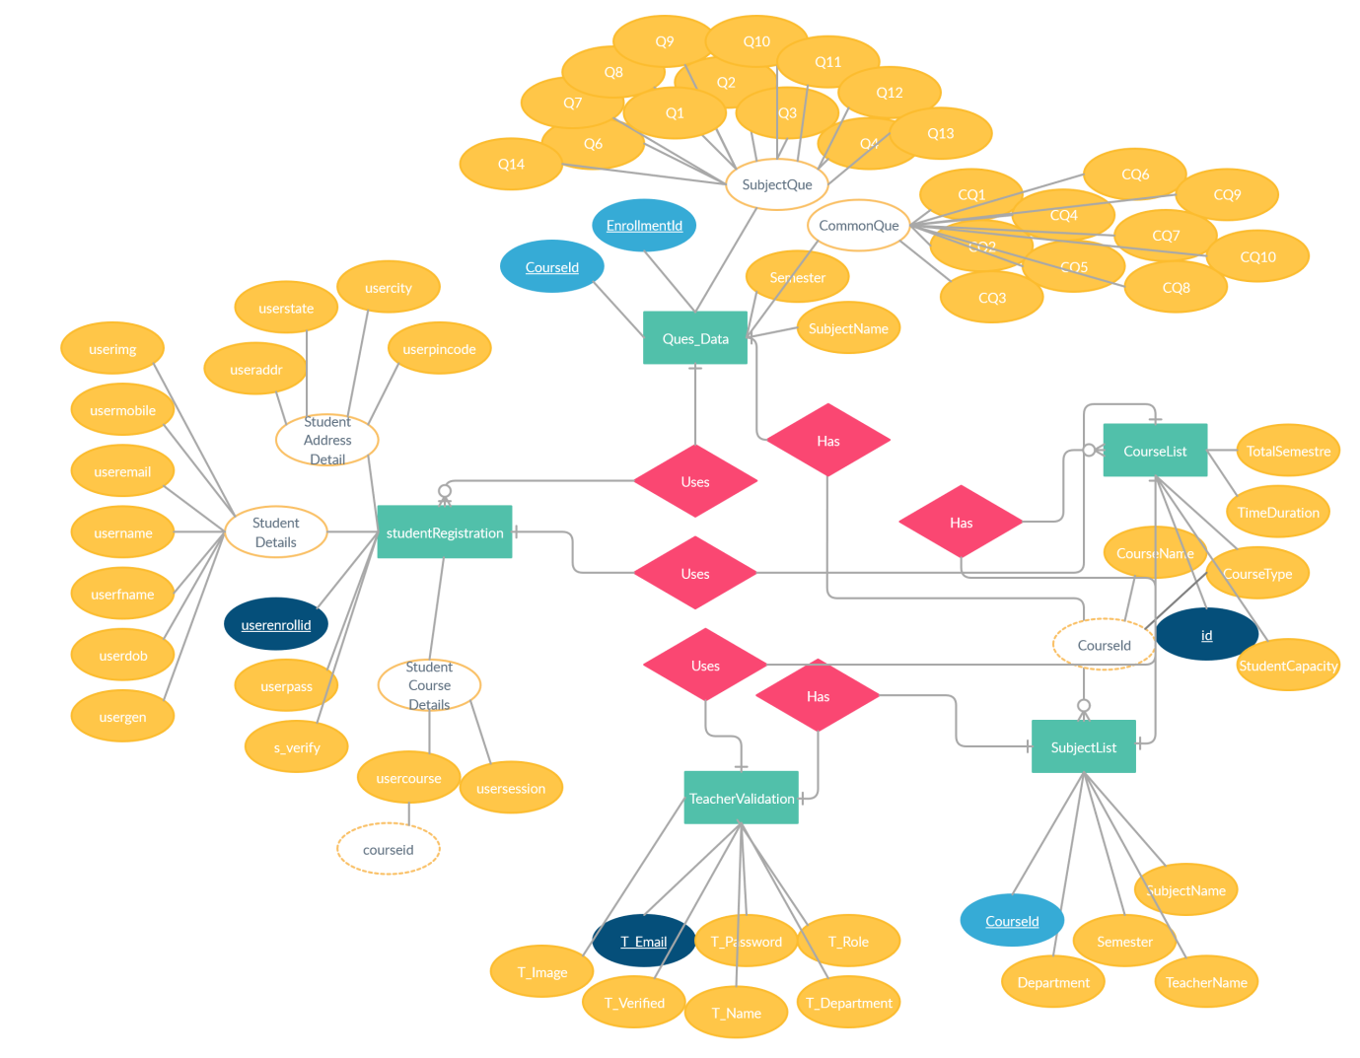

ER Diagram (1)

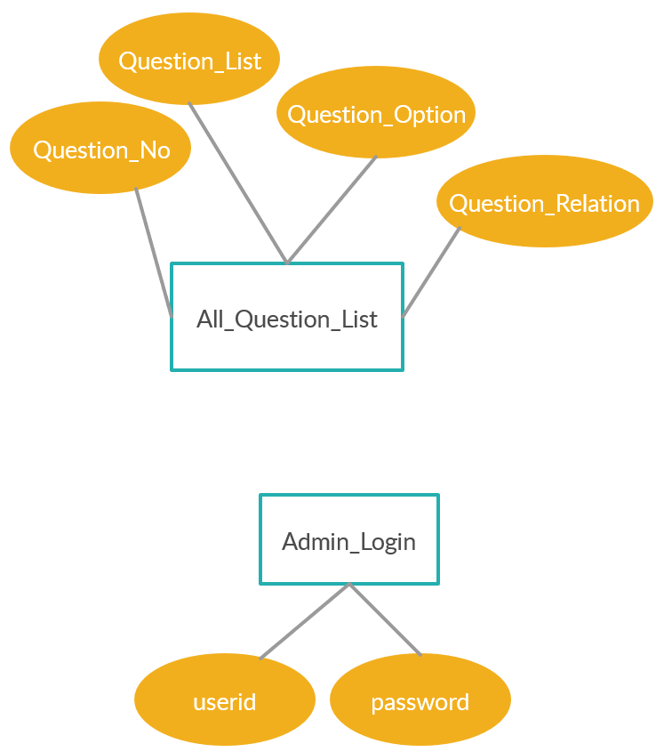

ER Diagram (2)

**Data Flow Diagram**

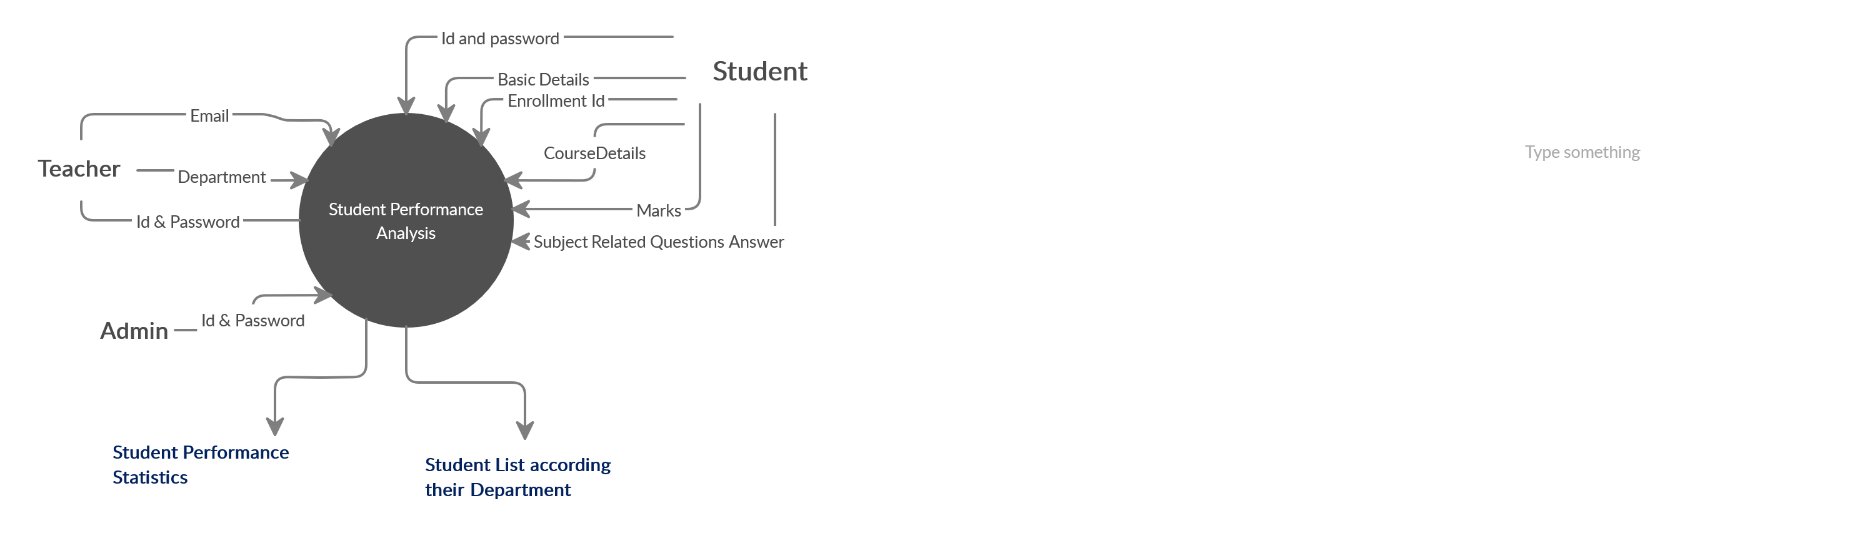

**Leval (0)**

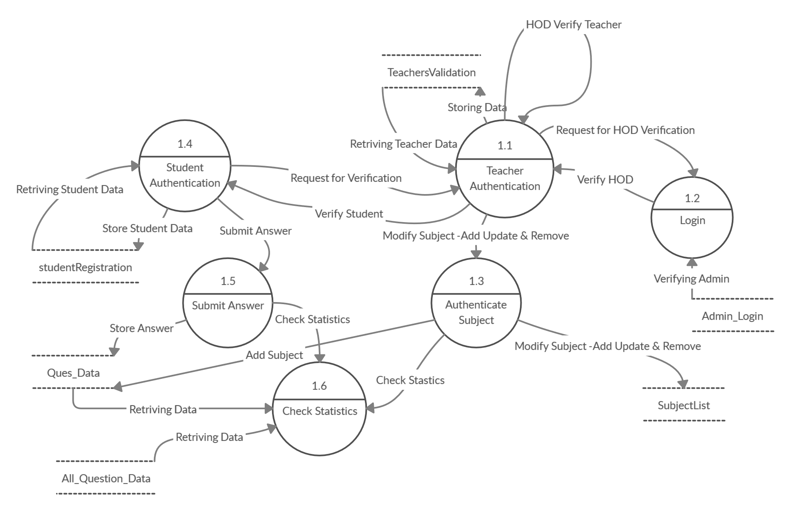

**Leval (1)**

**Screen shot**

**Index page**

* View for desktop:-

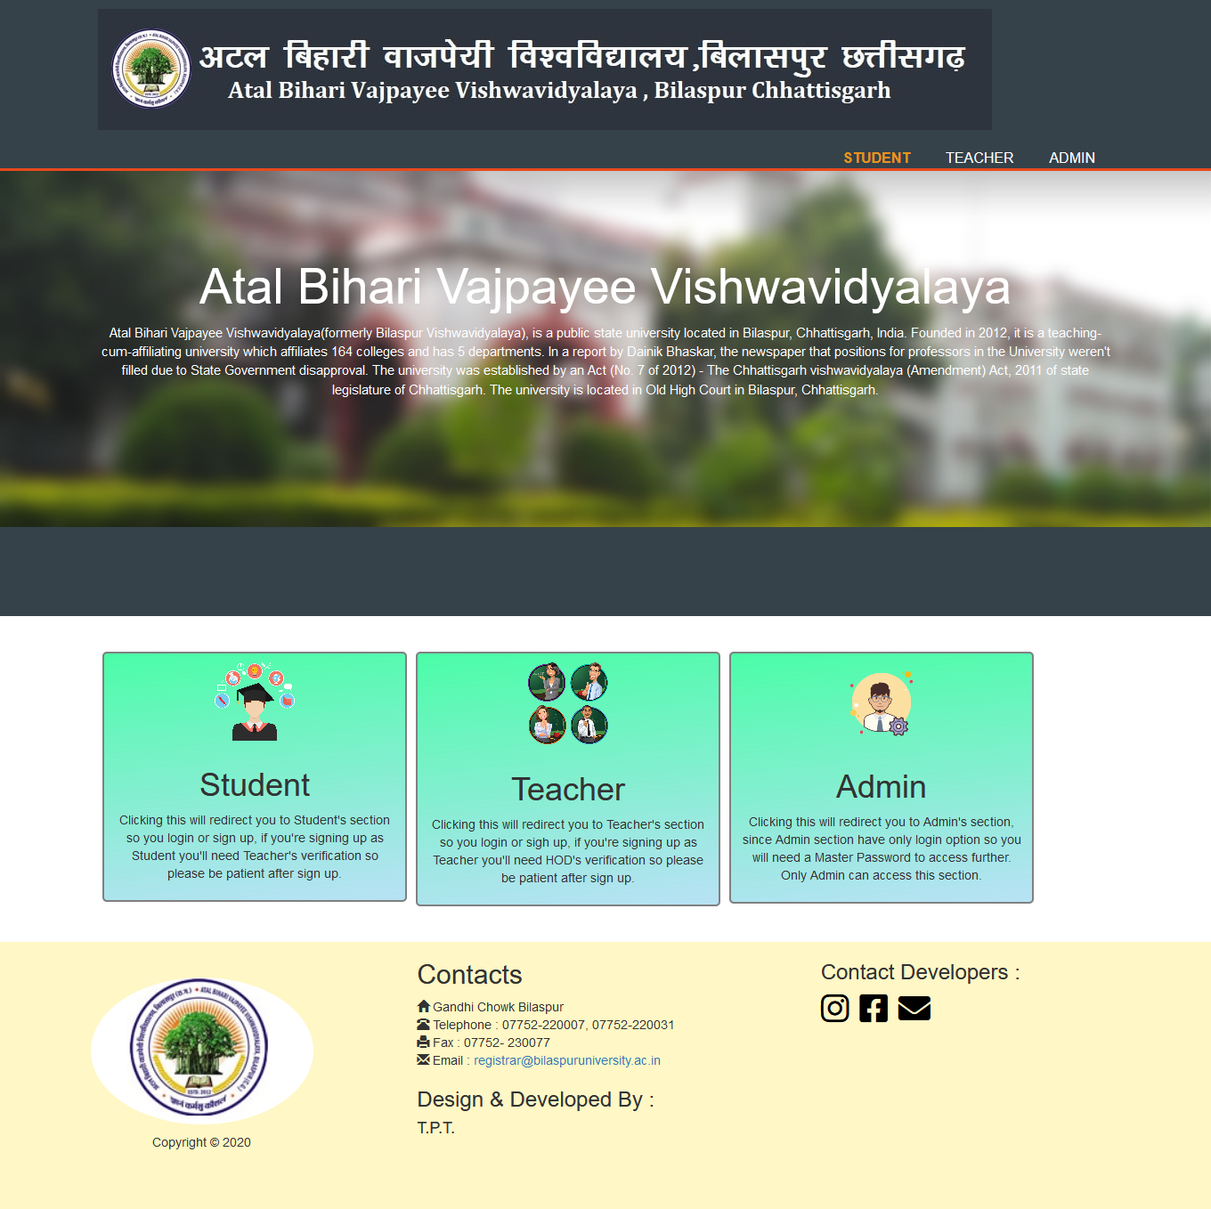

* View for smartphone:-



* View for tablet:-

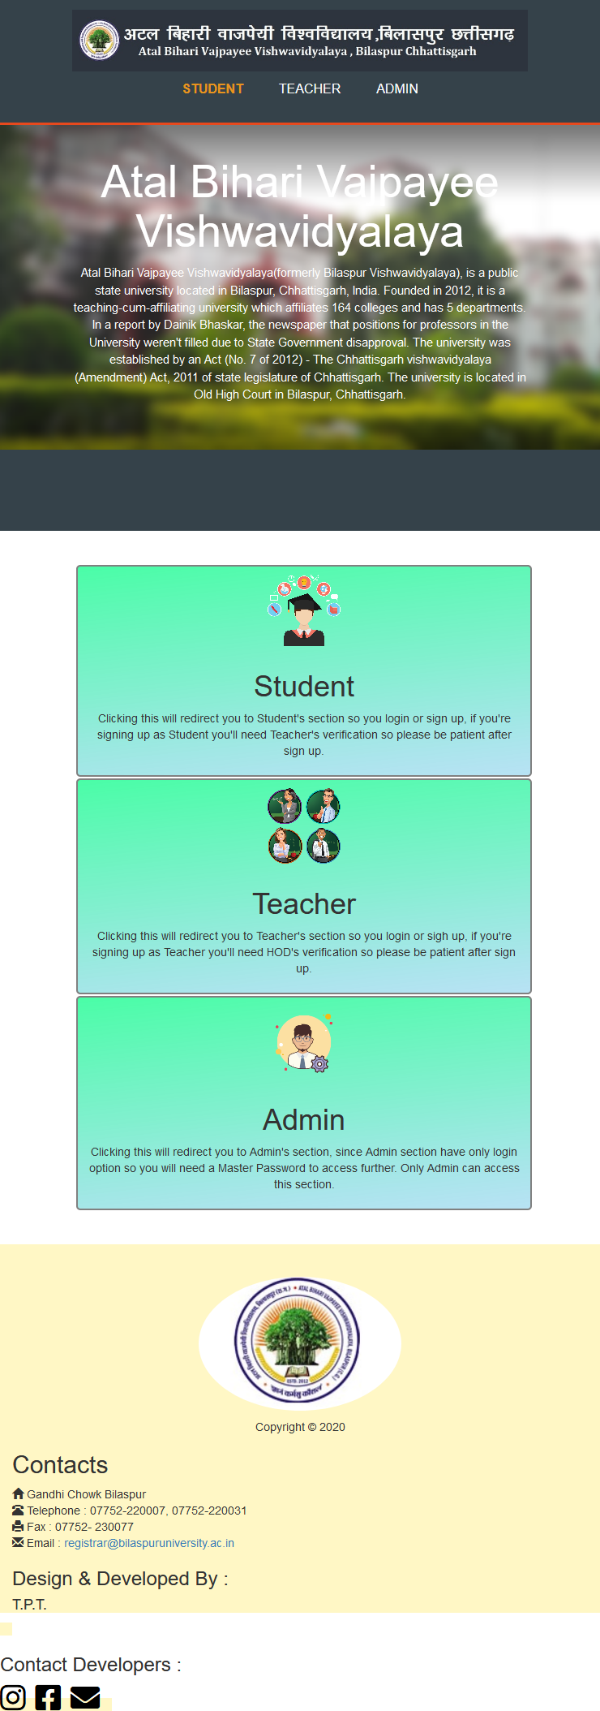

**Student login**

* **Student will enter his/her enrollment id and password and click button for login**
* **For smartphone user:-**

**Login page**

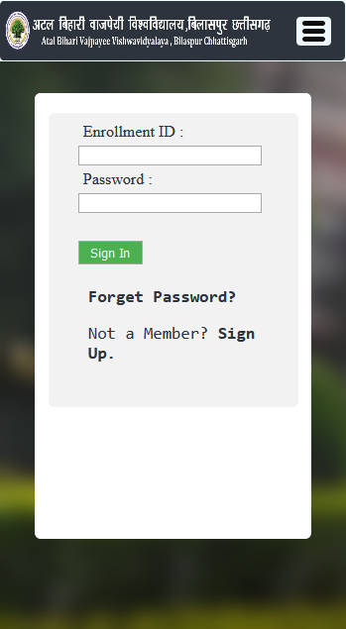

**Student homepage**

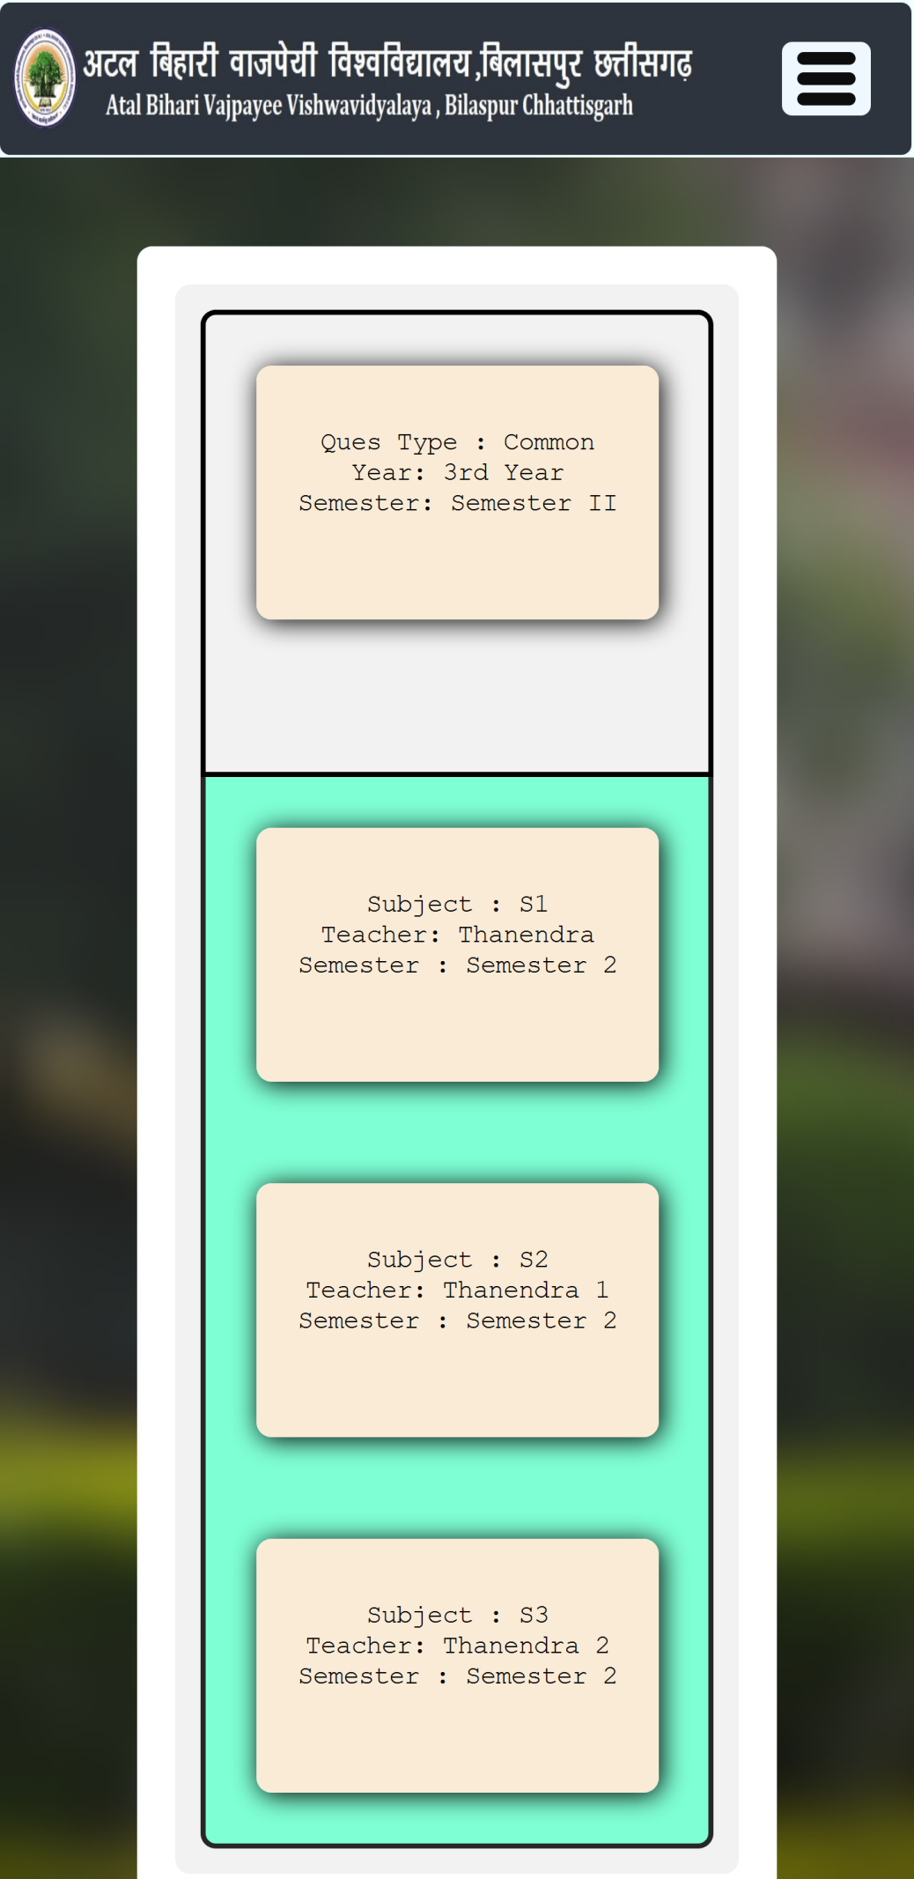

**Student profile page**

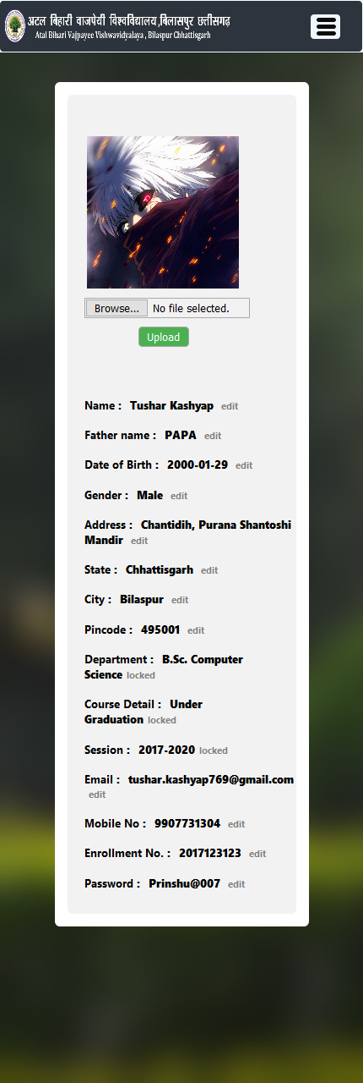

**Student statistics page**

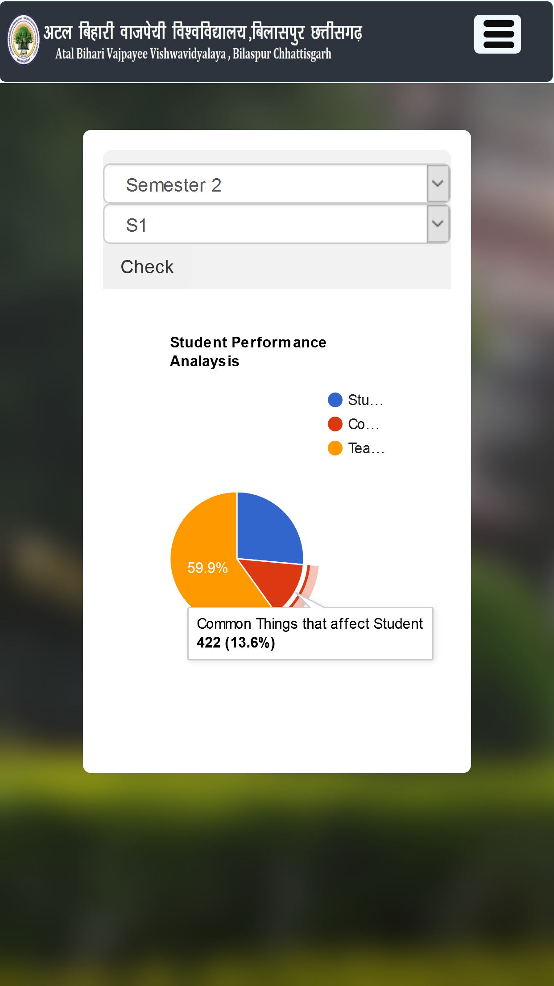

**For desktop and tablet user:-**

**Login page**

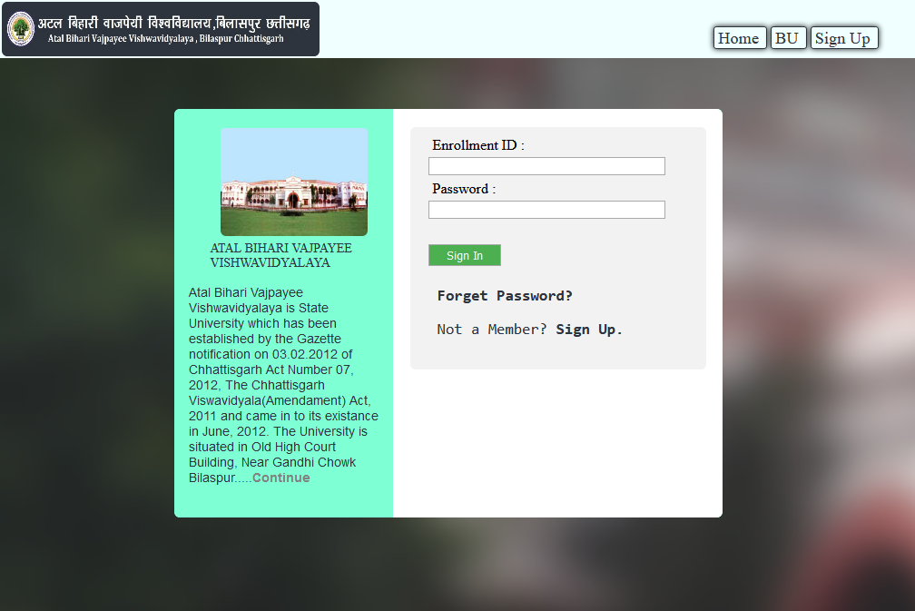

**Home page**

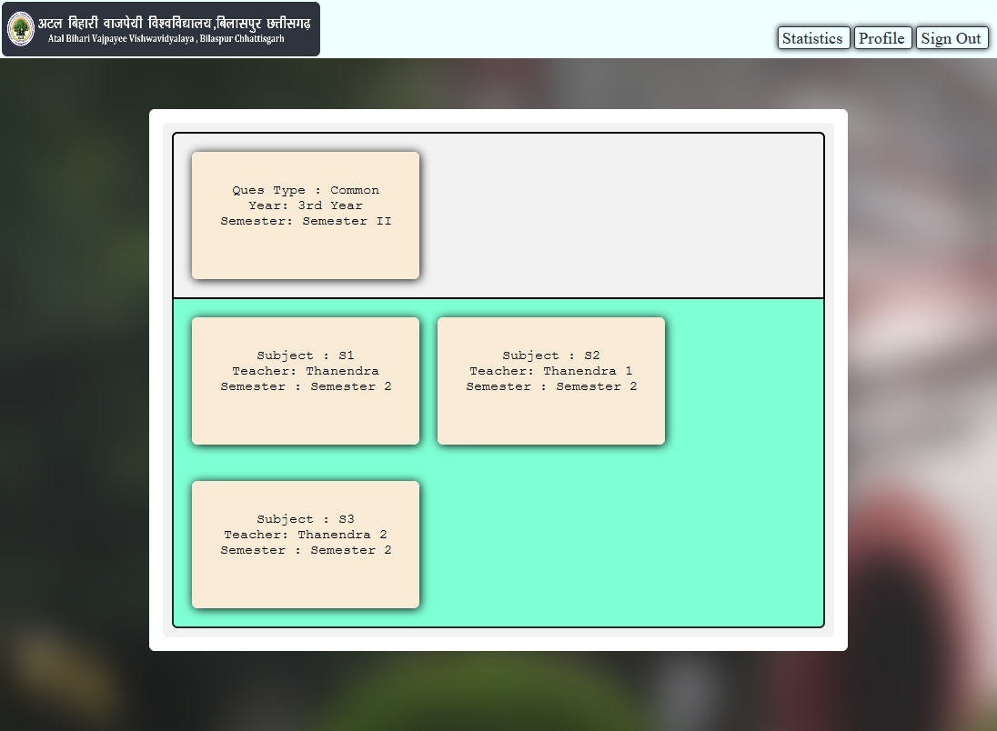

**Student profile page**

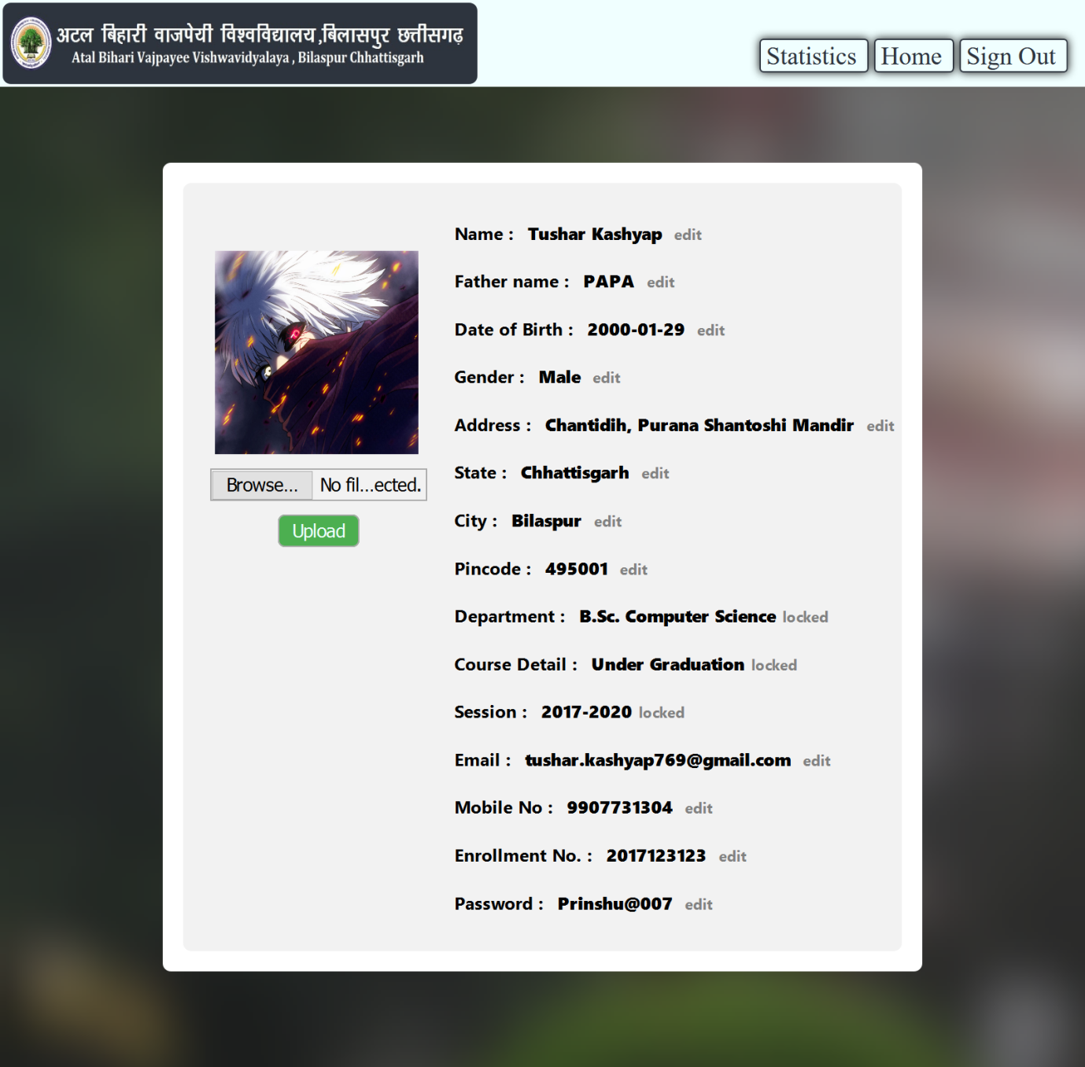

**Student stastistics page**

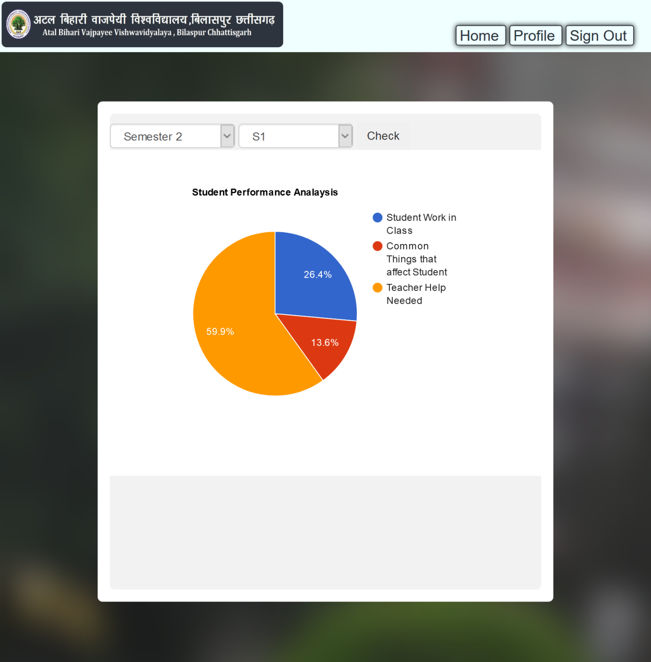

**Teacher login**

**For desktop – in this website, the teacher can login only in the desktop.**

**Teacher sign up page:-** teacher creates your profile here.

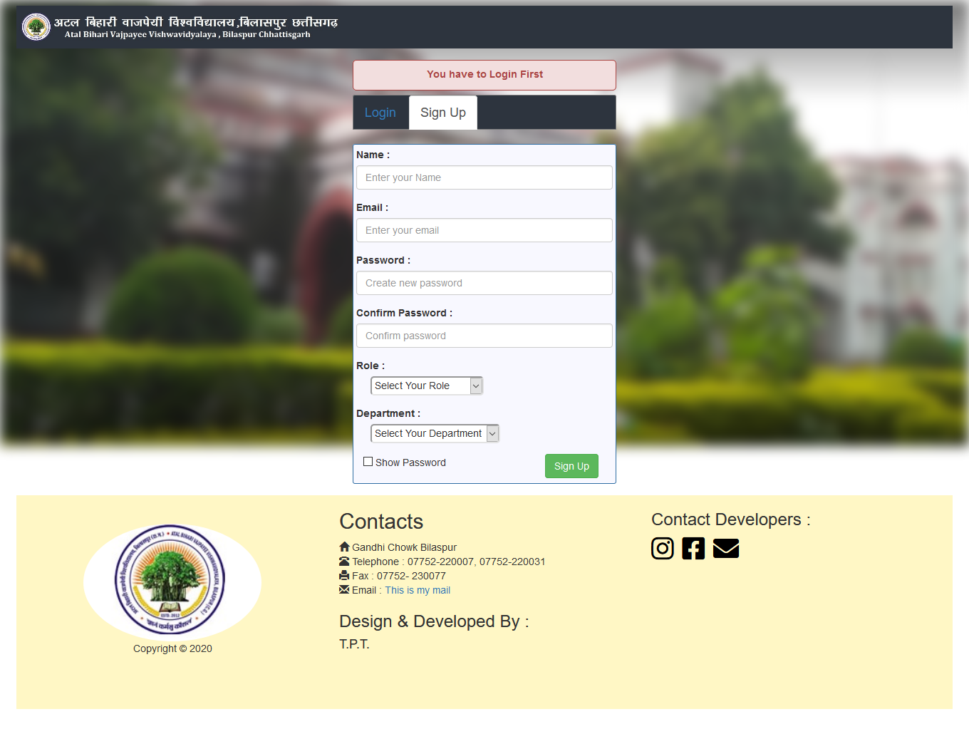

**Teacher login page:-** aftersigning up, the teacher can login by entering email id and password here.

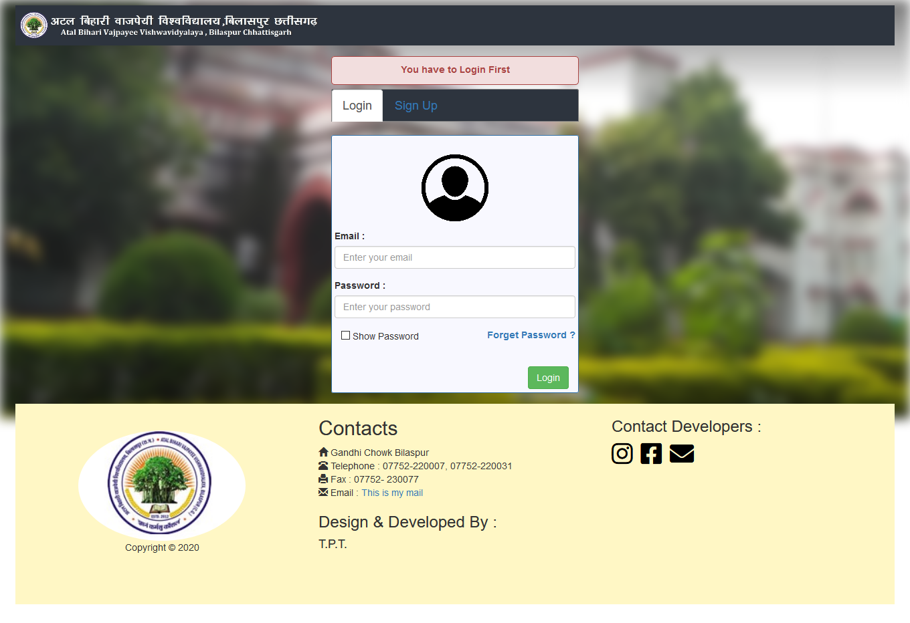

**Teacher profile page**:- teacher can see his profile here in this page.

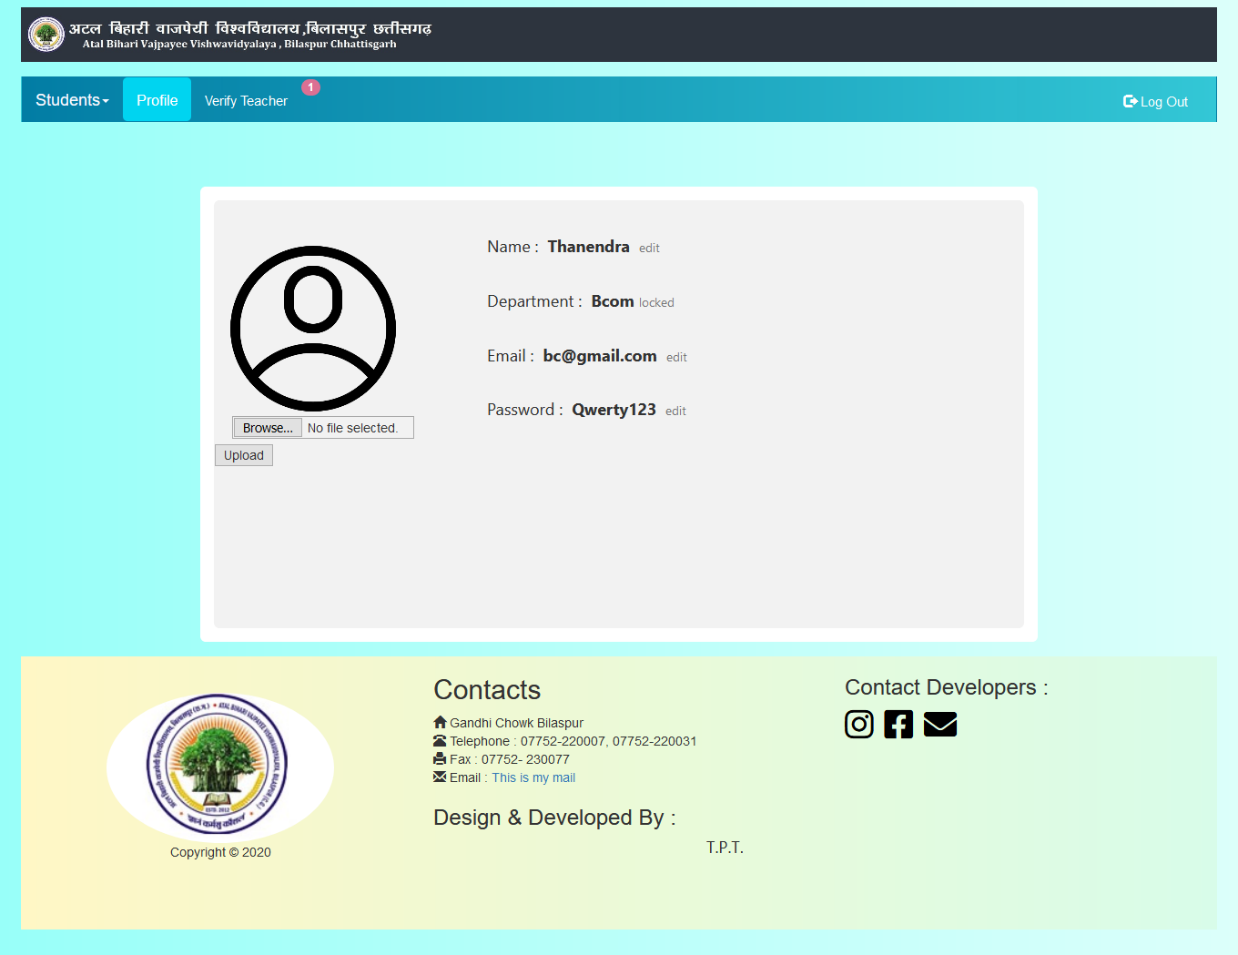

**Verify teacher**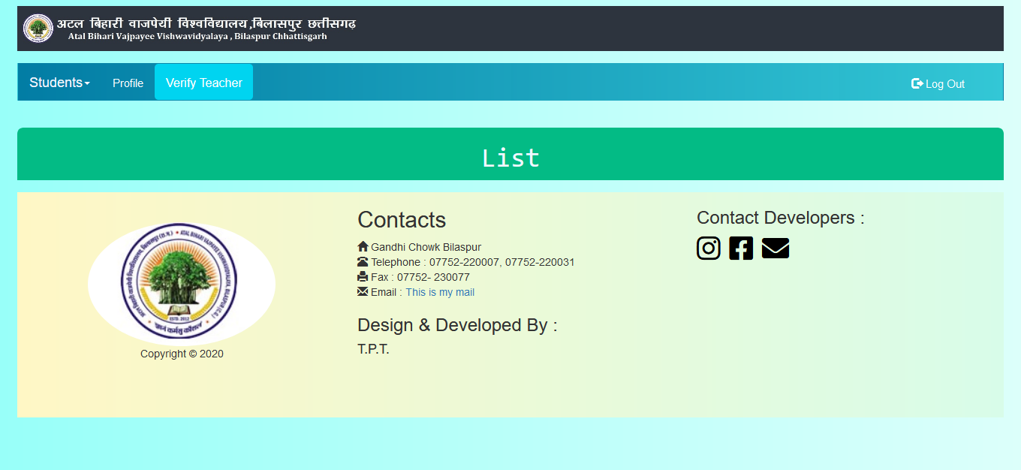

**Course modification:-** in the course modification page, the user can do the add course, the course can modify and can remove the course.

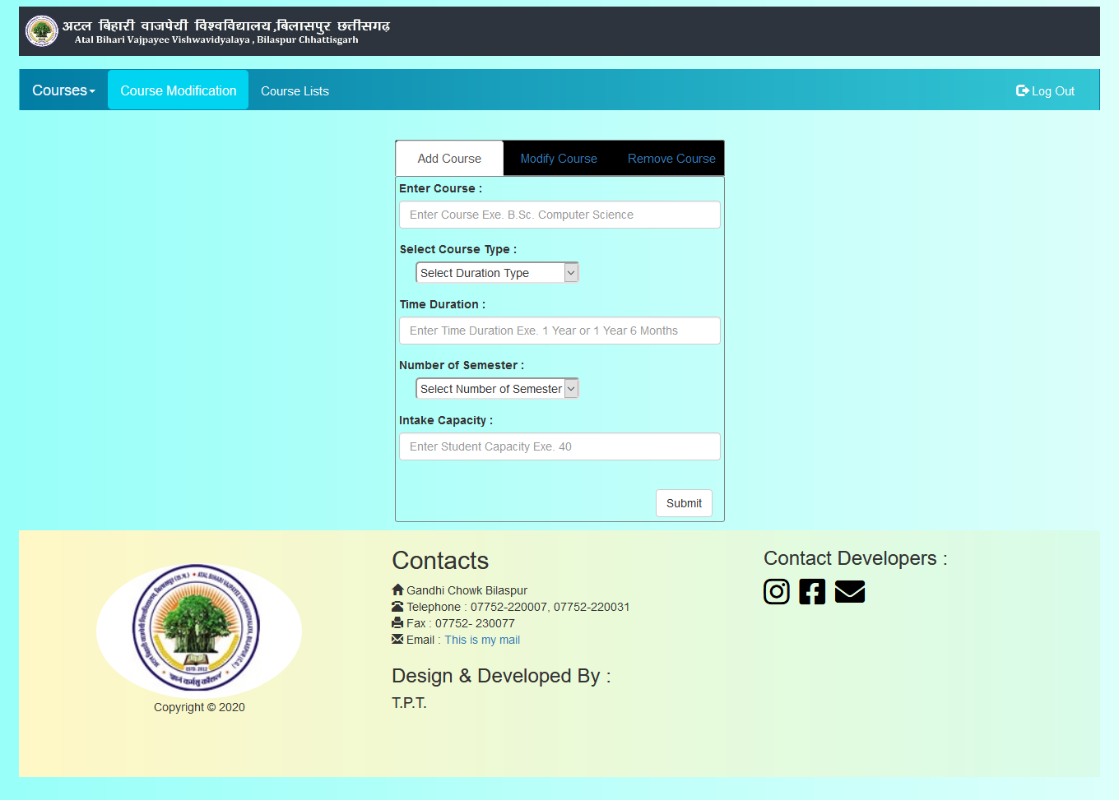

**Course list:-** by clicking on the course list button, the user can see the course name and related information from it.

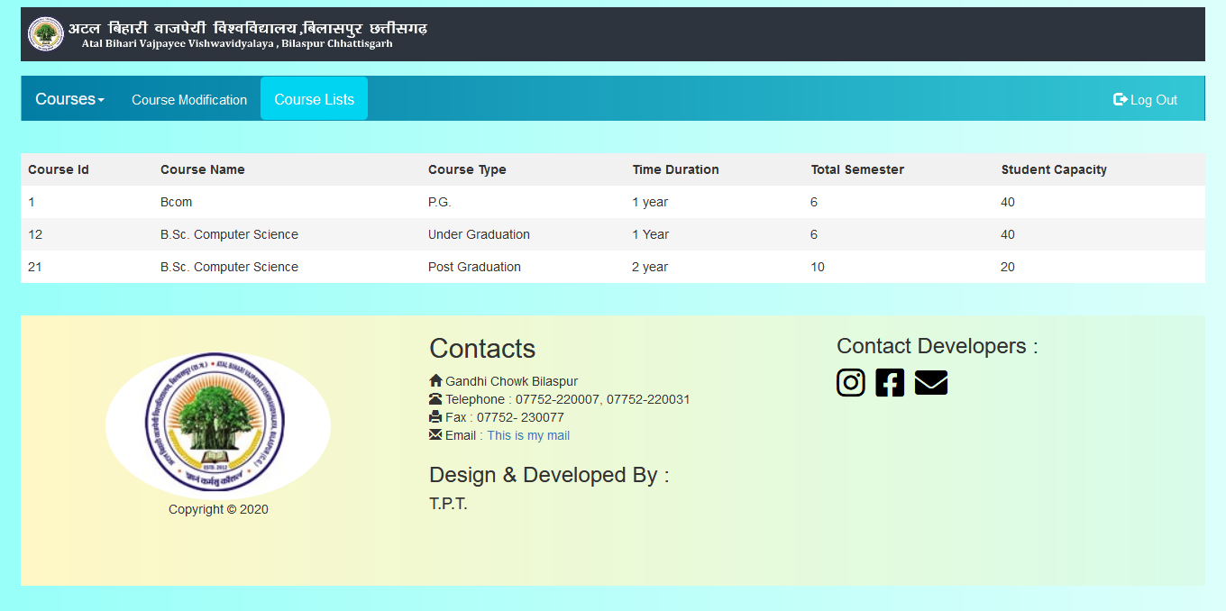

**Subject modification:-** by clicking on the subject button, the user can add the subject. Can modify and remove.

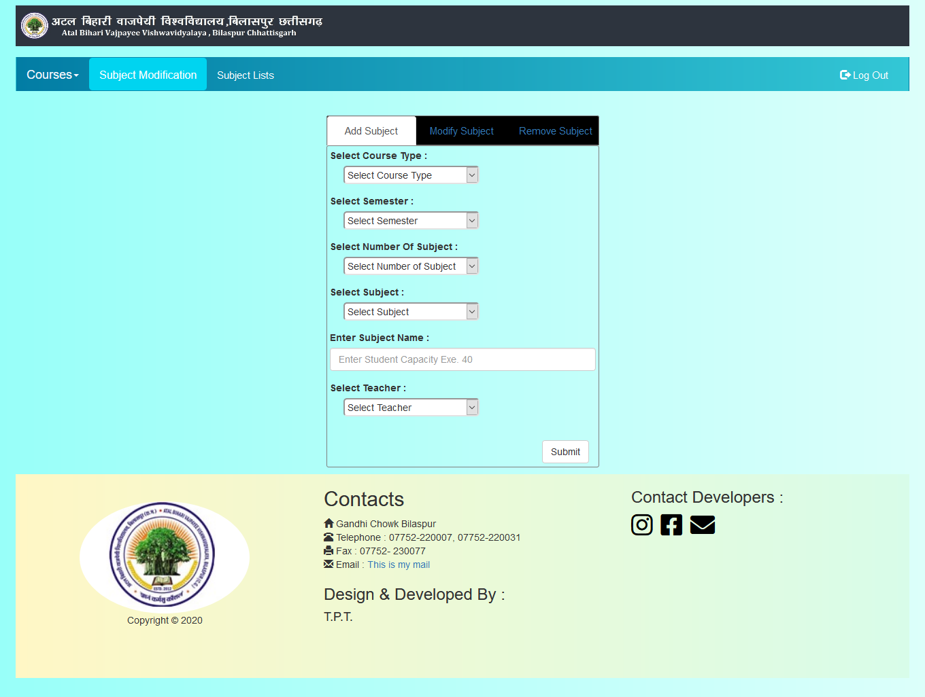

**Subject list:-**

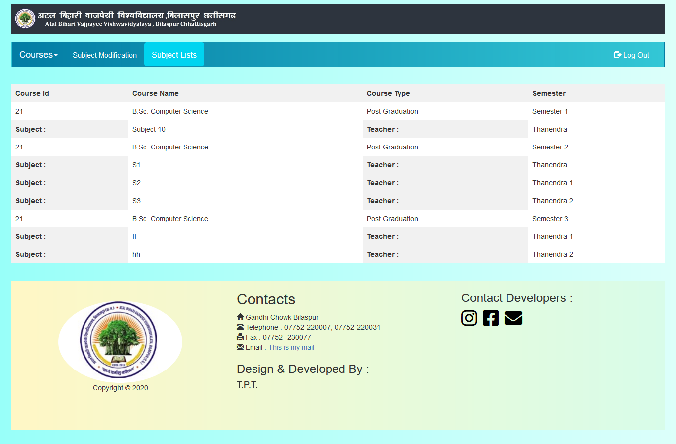

**Verify student:-**

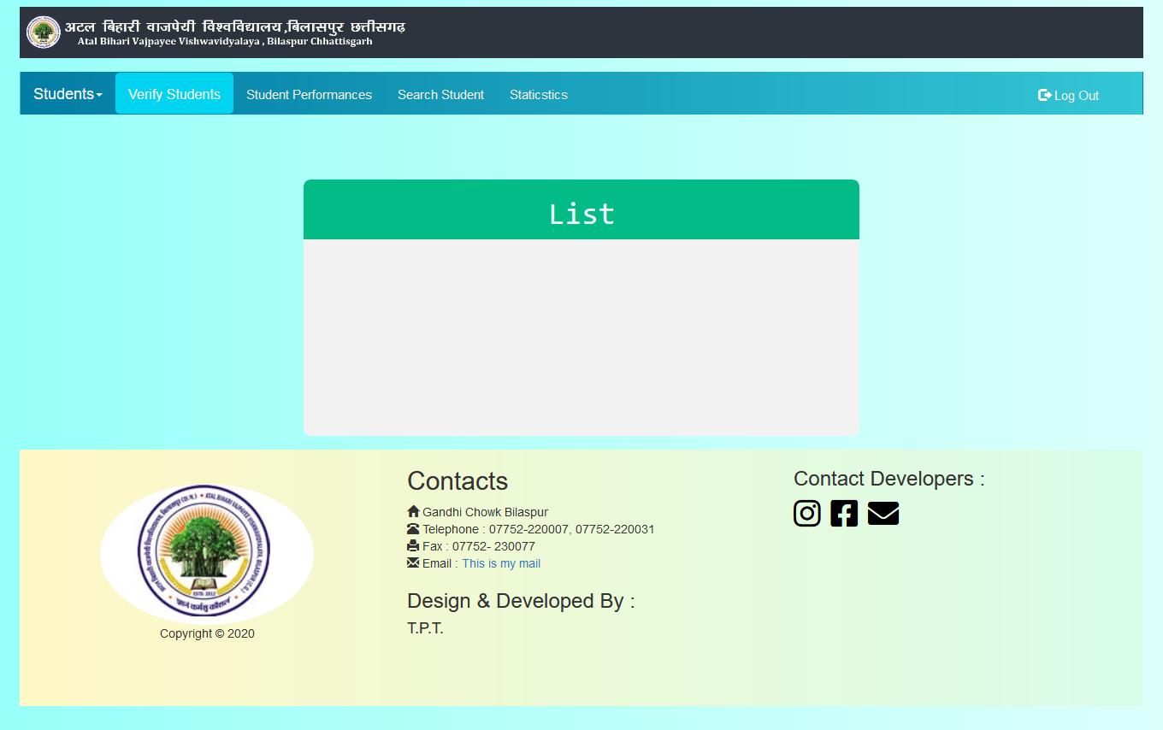

**Student performance:-** in the student performance page, the user can see the students name and their performance after clicking the view button.

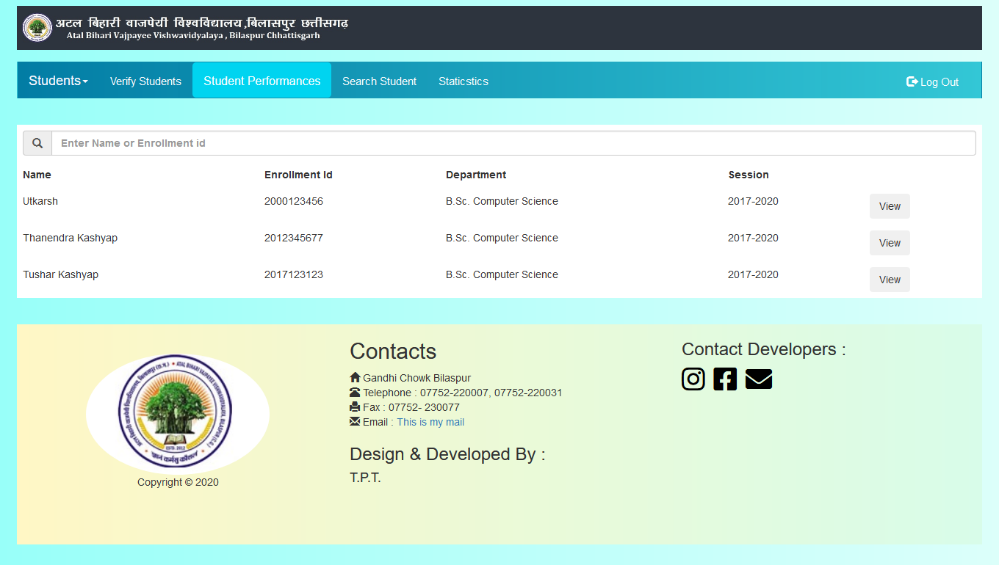

**Student performance graph:-**after collecting the semester all subject in this page,the performance graph of thr student appears after clicking on the cheak button.

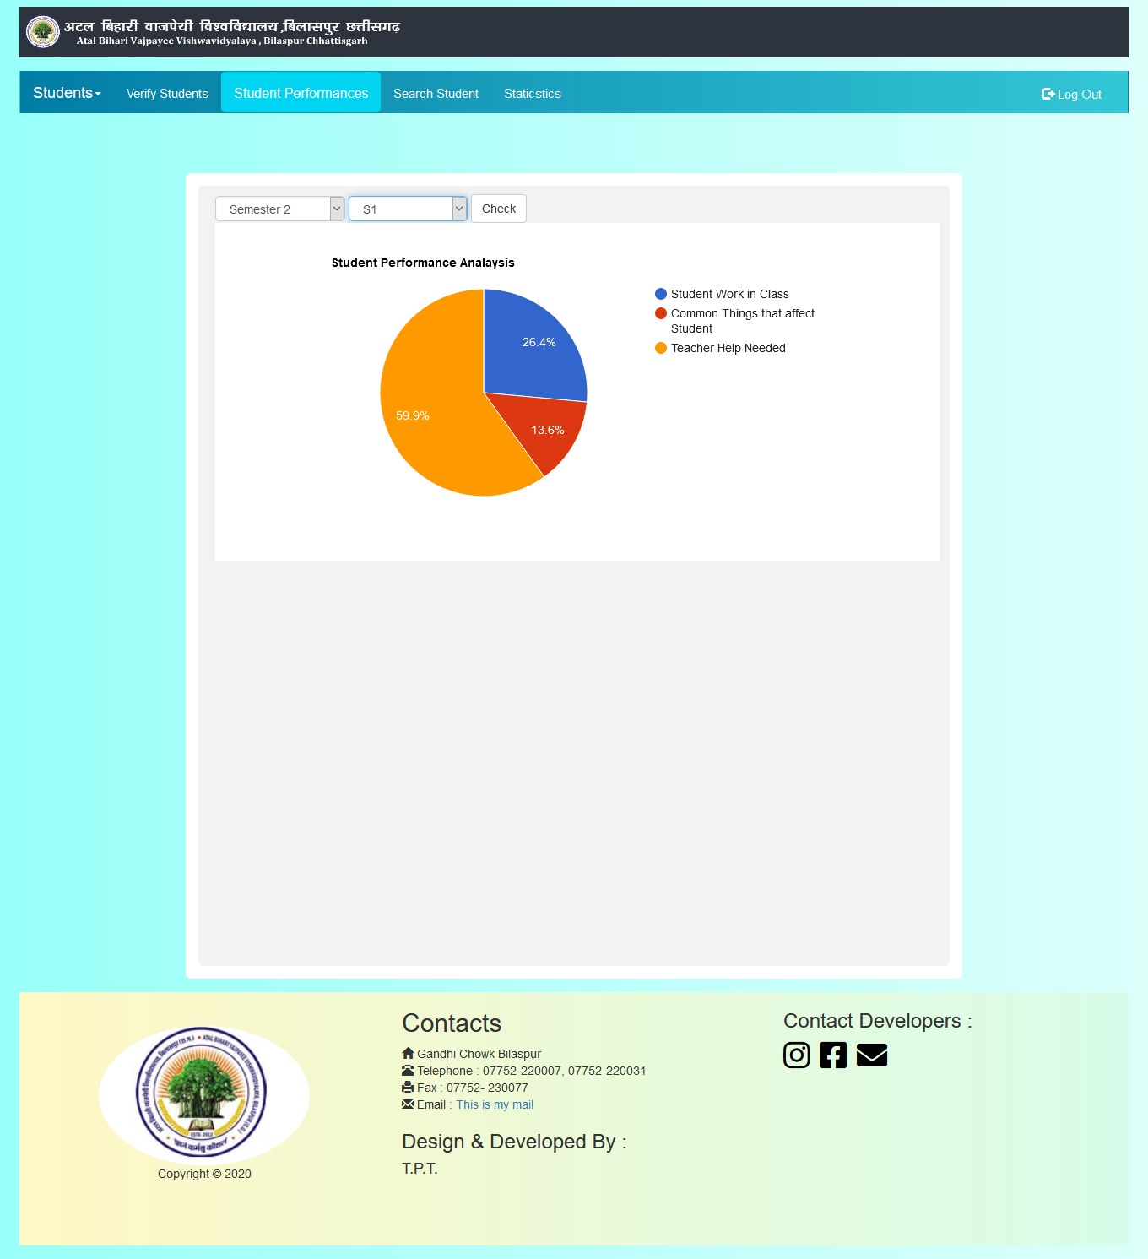

**Statistics student:-** in this page, after Performing the course,subject and semester and after answering some given questions,the students performance shows.

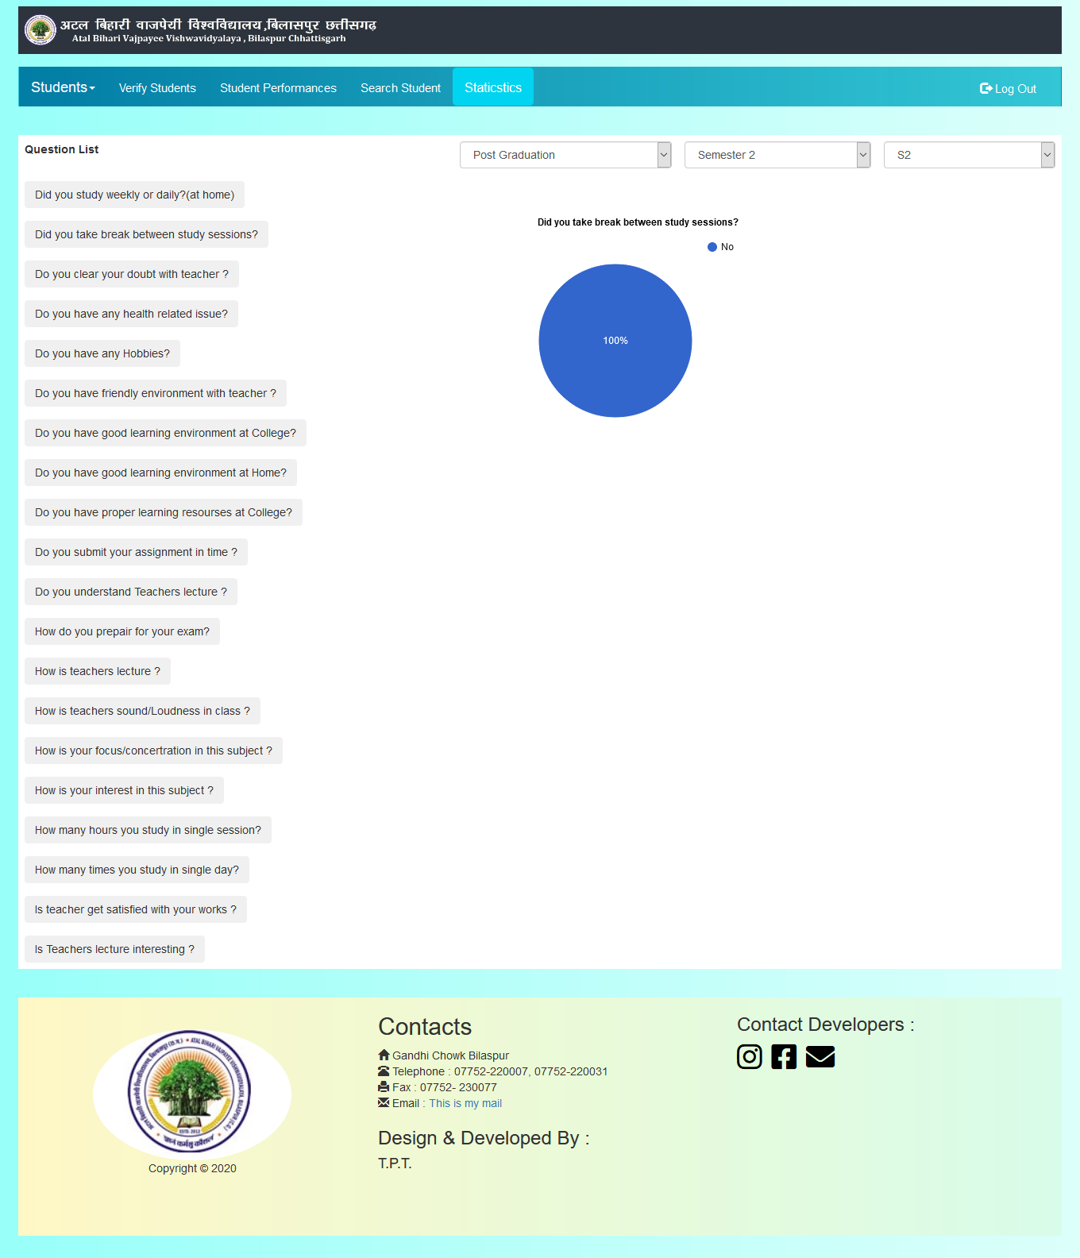

**Search student:-** in this page, we can search for verified students. Enter their email id or enrollment number.

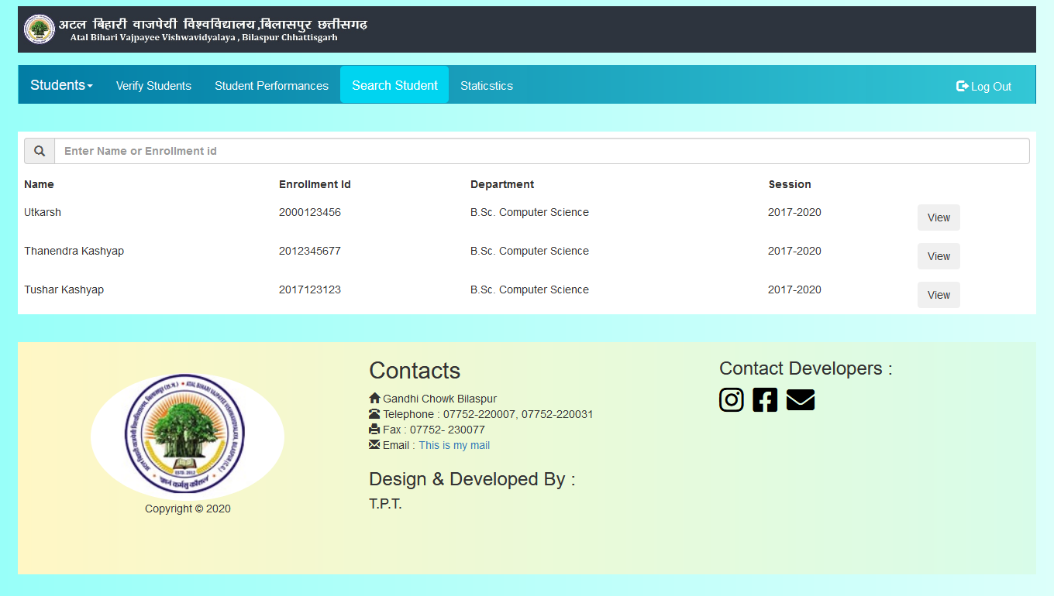

**Admin login**

**Login page:-** respected admin can login with the help of user id and paaword.after clicking the admin button in the index page.

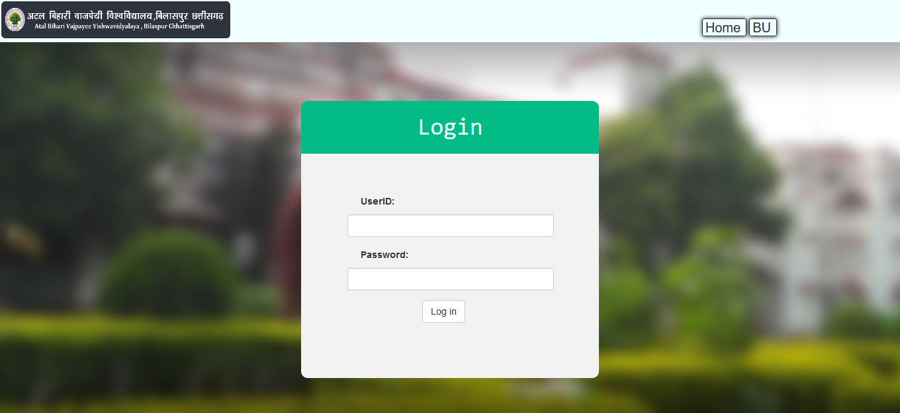

**Hod Unverified list:-**this page contains the list of an unverified hod list that the administrator verifies.

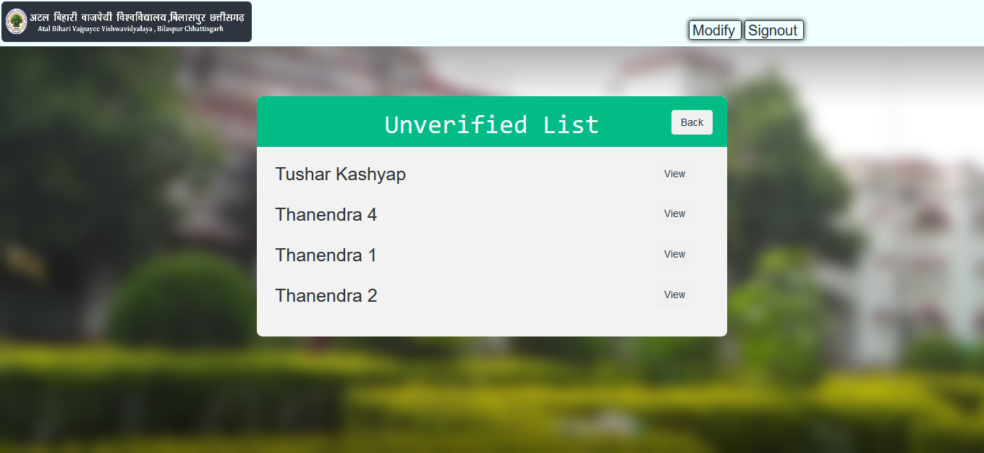

**Hod verified list**:- user admin can view the list of verified hods and their profile here.

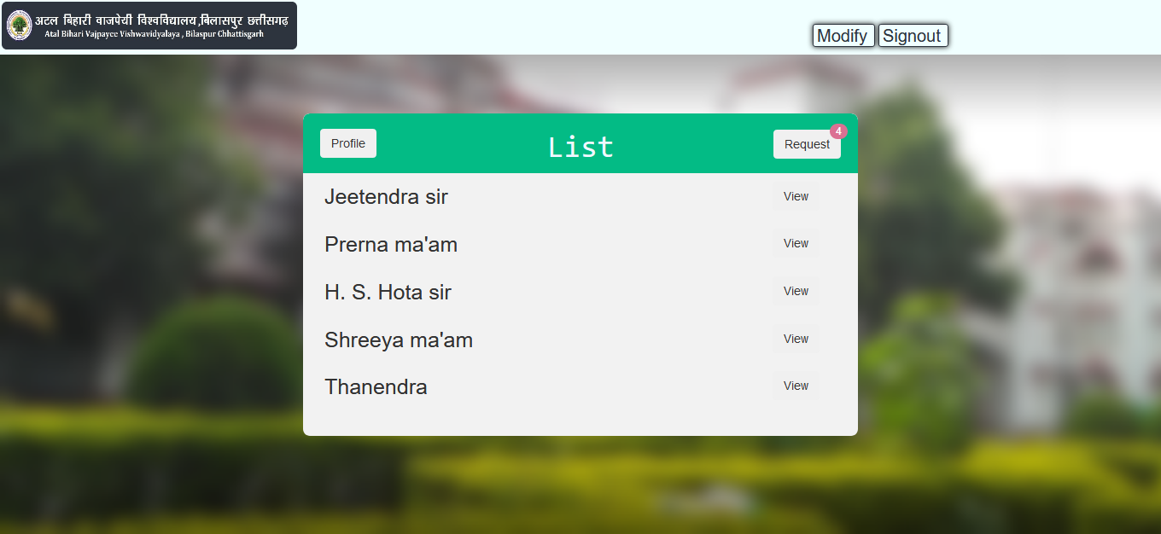

**Conclusion**

The online student performance analysis form is developed using Visual Basic.NET fully meets the objectives of the system which it has been developed. The system has a steady state where all bugs have been eliminated. The system is operating at a high level of efficiency and all the teacher and user associated with the system understands its advantage. The system solves the problem. It was intended to solve as requirement specification.

**Reference**

* Pro ASP.Net 4 in C#2010, Matthew MacDonald, Apress.
* Beginning ASP.Net 4 in C# 2010, Matthew MacDonald, Apress.
* Tutorial Point
* Internet , Youtube